EvaluateIt! 1.0 Mobile Garden Application
User Manual



This guide is a brief overview of how to use the EvaluateIt! mobile garden evaluation application.

The EvaluateIt! mobile application has been dev eloped to work on both the iOS (iPhone/iPad) and Android platforms.

Installation of EvaluateIt!

Installation of EvaluateIt! is done “over the air” by using the TestFlight Web service. You will need to create an account and register your mobile device at https://testflightapp.com. You will receive an e-mail when the application is ready for distribution. Using your mobile device, follow the directions in the e-mail to install or upgrade your version of EvaluateIt! If you encounter any problems, please e-mail me the details of what you were trying to do and any errors you have encountered.

NB: Always make sure that all completed evaluations have been uploaded to the MetroBlooms Web server before upgrading to a new version of the EvaluateIt! application.

Use of EvaluateIt!

The EvaluateIt! mobile application is meant to be a replacement for the paper copy of the “Minneapolis Garden Evaluation Form” developed by Metro Blooms for use in the Minneapolis Garden Evaluation program. EvaluateIt! also allows the evaluator to capture an image and the GPS coordinates of the garden being evaluated.

EvaluateIt! consists of two main sections: “Manage Evaluations” and “Manage Data.”
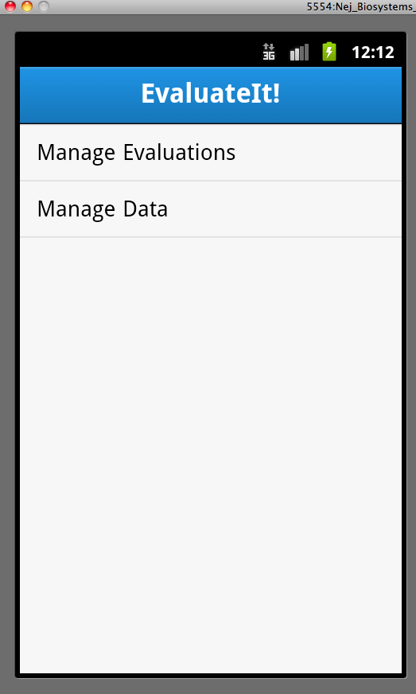

Manage Data

The main functionality here is loading to your mobile device those evaluations that have been assigned to you from the Metro Blooms Web site, and uploading completed evaluations from your mobile device back to the Metro Blooms Web server.

Loading data from the Metro Blooms Web server on to your mobile device is considered to be a “Pull” operation, while uploading evaluation and image data back to the Metro Blooms Web server is a “Push” operation.
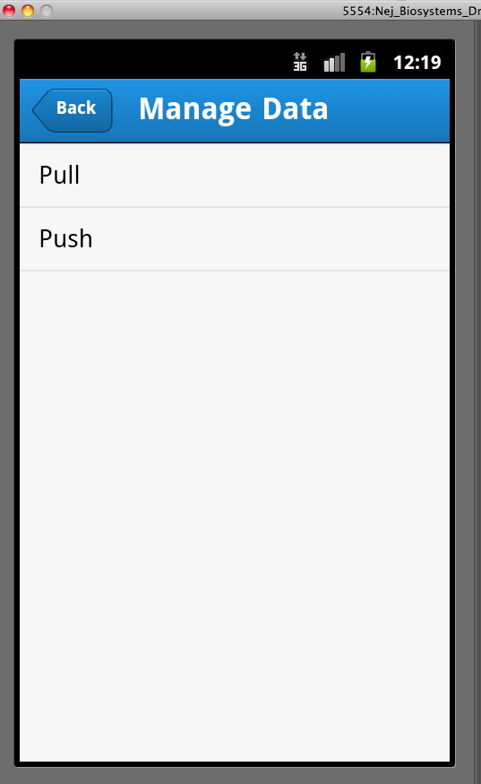

To Pull data

First tap on the “Login” button and then enter your username/password that you use to log into the Metro Blooms Web server for managing your evaluations. If you do not yet have an account, please register at: http://metroblooms.org/signin_user.php
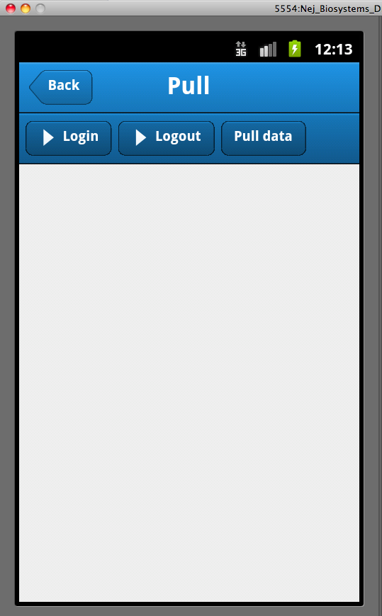

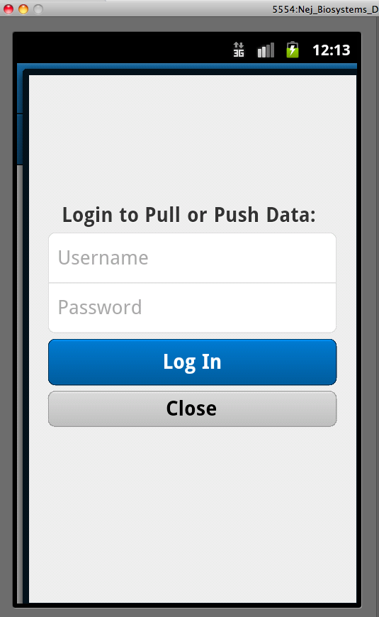

Once you have successfully logged in, you will receive an alert with your name.
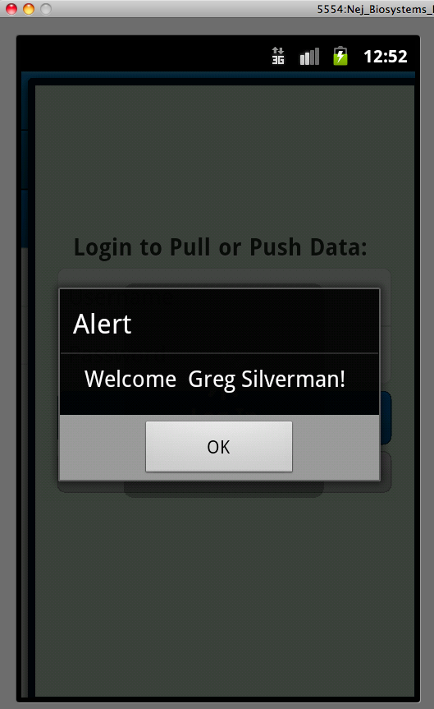

Tap on "Ok" and you can now load the evaluations assigned to you by taping on the “Pull data” button. If successful, you will see data output on to your screen.
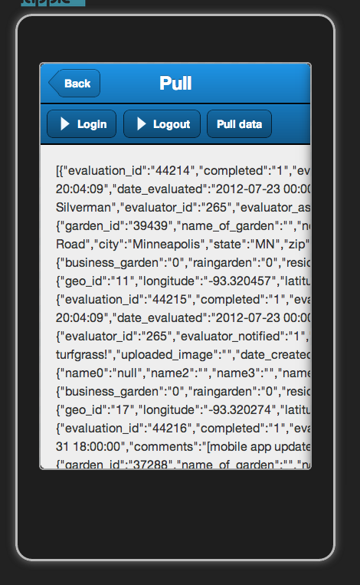

NB: Push/Pull operations should all be done using a wifi network connection (versus 3/4 G), both for faster transmission rates, for better reliability and to ensure you do not incur data usage charges form you service provider..

Manage Evaluations

The main functionality here is to complete the evaluation of particular garden you have een assigned to evaluate, as well as any new gardens that while they have not been assigned to you, you deem worthy for a nomination/evaluation.
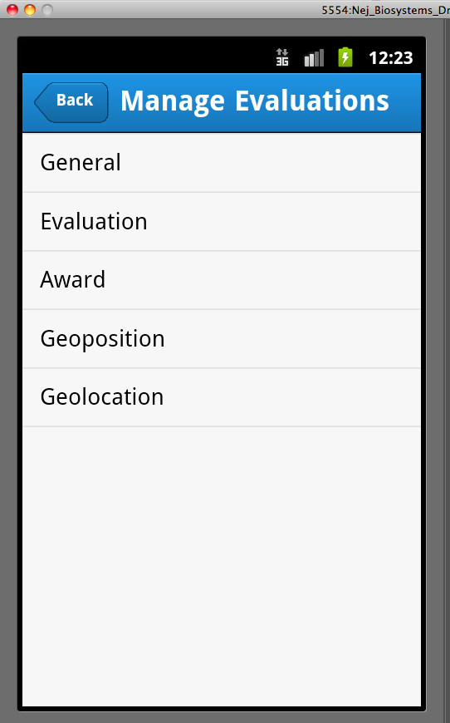

General form

Tap on the General button to show a list of existing evaluations that are assigned to you or have been added by you.
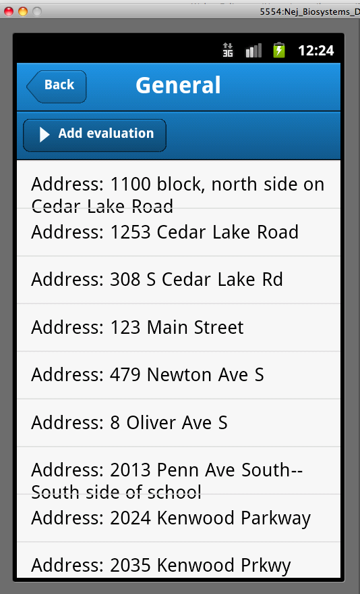

Here you can:

Add a new evaluator nominated garden for evaluation by tapping on the “Add evaluation” button and completing the data items in the given form, followed by tapping on the "Save" button at the bottom of the form.
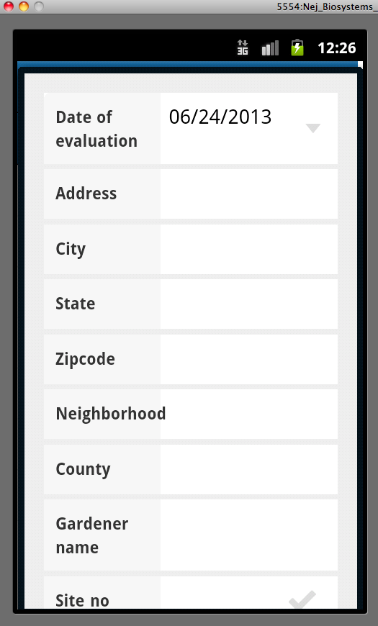

By tapping on any address already in the list, including those that have been assigned to you or any newly nominated gardens you have added, you can

- Manage evaluation addresses
- Mark a garden as “No longer exists”
- Add the name of the gardener
- Add any general comments

Once you have added or made your desired changed, tap on the “Save” button. You can always go back and make any changes to evaluation data.

Evaluation Form

Here is where you enter the 5-ratings found on the “Minneapolis Garden Evaluation Form.” It is also where you can tie an image to the evaluation.

NB: Use your mobile device's camera to capture as decent a picture of the garden as possible. This is done outside of the EvaluateIt! application. You can then associate your "best" image to the evaluation record at any time within the EvaluateIt! application by tapping the “Select Photo” button and then choosing the image from your mobile device's photo gallery or library.
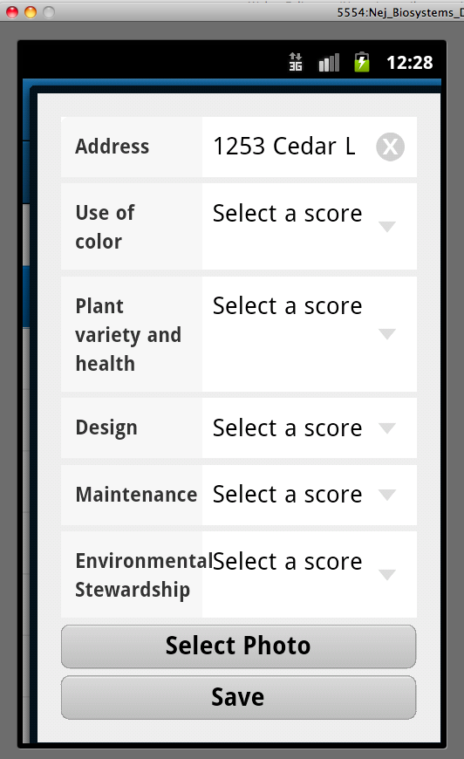

Once done entering the evaluation data and/or linking an image to the evaluation, tap on the
“Save” button.

Award Form

Here is where you assign any award you deem the garden worthy.
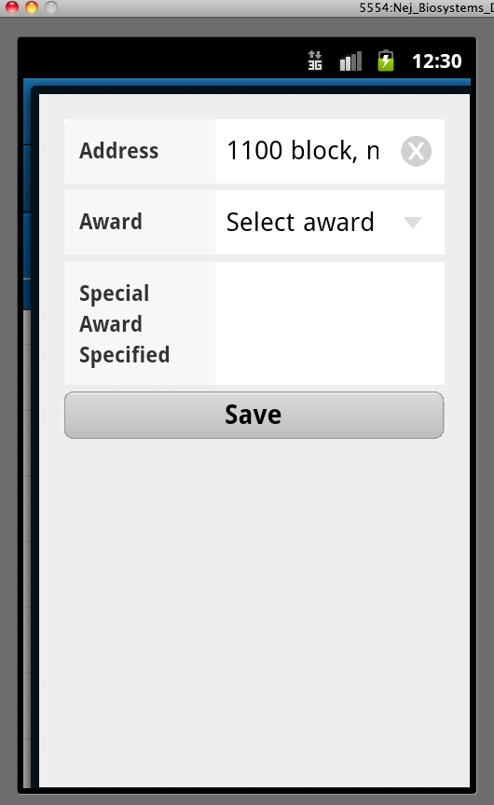

Once done entering any award information, tap on the “Save” button.

Geoposition Form

Here is where you will obtain the GPS coordinates of the garden you are evaluating.

To obtain the GPS coordinates, tap on the “WatchPosition” button.
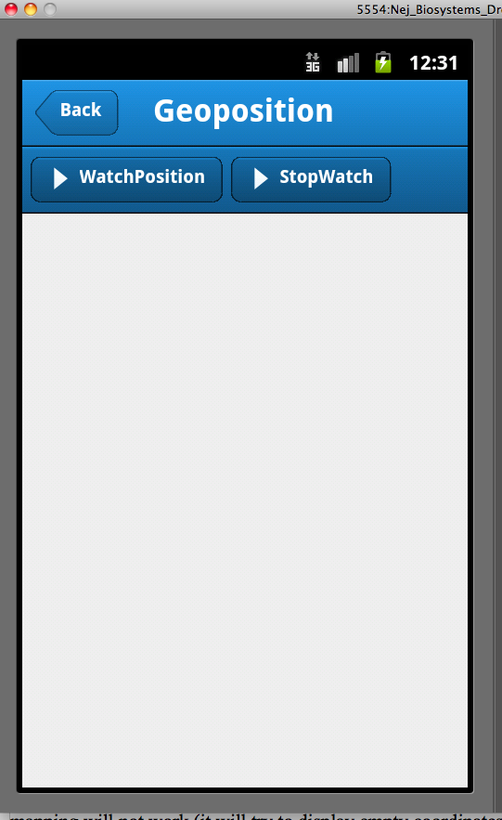

You will keep receiving alerts with the current accuracy (in meters) of the most recent GPS reading.
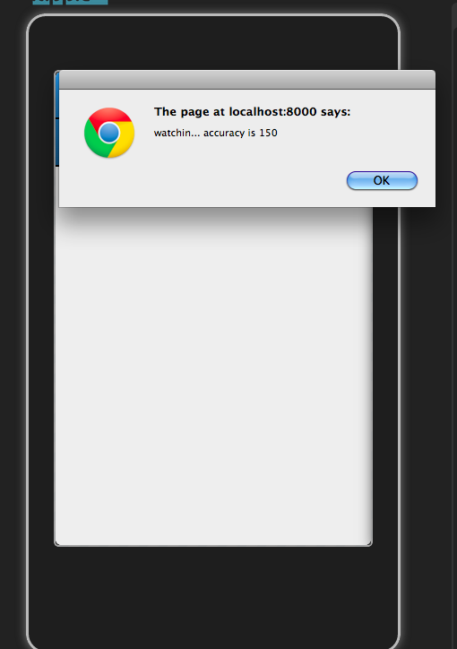

Once an accuracy of 30 meters or less is achieved the coordinates will be available to view your location on a map and then save.
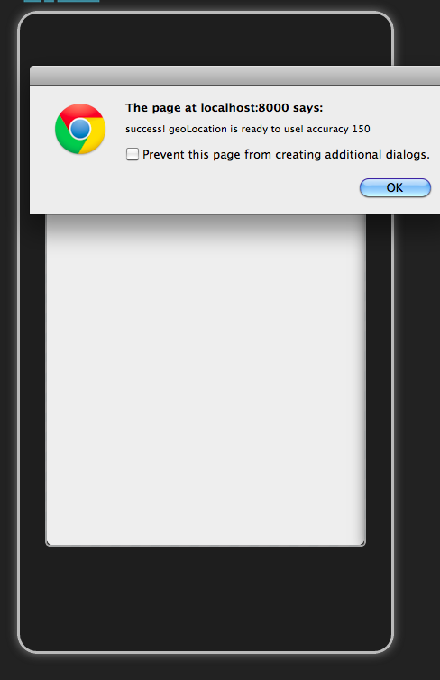

NB: Higher accuracy may be more easily obtained through a 3/4 G connection in comparison to wifi, so if you are using the City of Minneapolis wifi network, you may need to experiment with this.

Also, please be aware that only when an accuracy of 30 meters has been reached will success be achieved. If you do not receive a lower accuracy after more than 4-5 minutes, you can tap on the “StopWatch” button and try again from a different location on site.

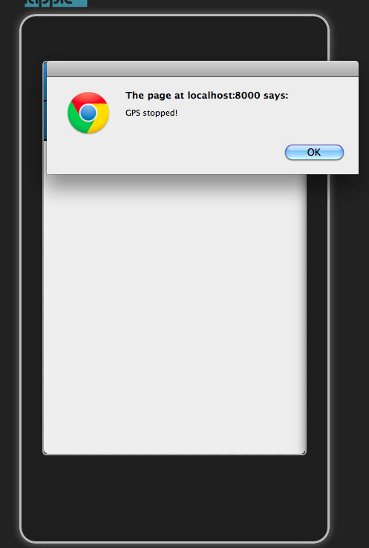

Geolocation Form

This allows to view your current position on a map and to save the obtained coordinates from the previous step. If you are satisfied with the mapped location (i.e., the position of the arrow on the map), you can then tap on the "Save location" button to write your coordinates to your mobile device's database. Once you have saved the geocoordinates, tap on the "Back" button to get to the previous screen.

NB: you can drag the map in any direction. To return to your current coordinates, click on the icon with a house.

If you are not satisfied with the results, you can retry capturing your GPS coordinates using the Geoposition form above. (Please note that in the image below you should see an arrow marking your current position).
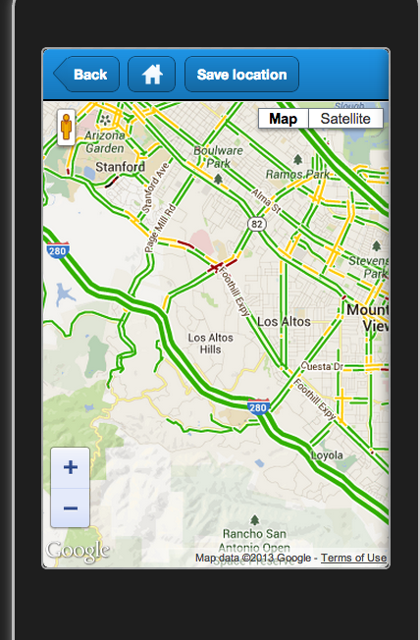

NB: You must run the Geoposition “WatchPosition” function first before doing this, otherwise the mapping will not work (it will try to display empty coordinates on the map and crash the application).

Manage Data (Push):

NB: Always make sure that all completed evaluations have been uploaded to the MetroBlooms Web server before upgrading to a new version of the EvaluateIt! application.

Here is where completed evaluations are uploaded to the MetroBlooms Web server. A list of "completed" evaluations (those either marked as “No longer exists” or those with all the 5-rating factors completed) will be displayed in the list. Tap on the address of the evaluation that you wish to upload.
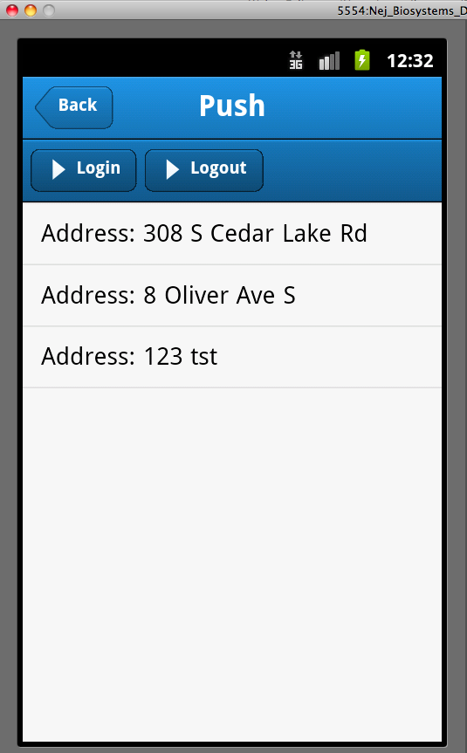

Tap on "push to server"
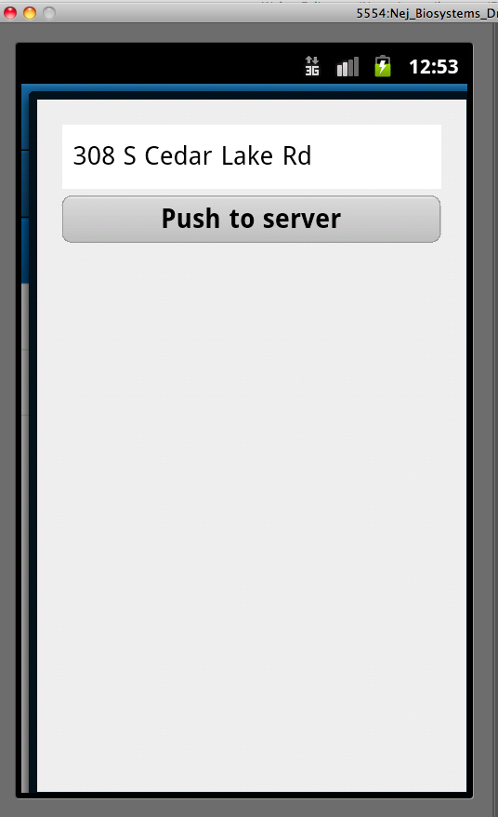

If successful, you will see a message indicating success for uploading the evaluation data for that address.

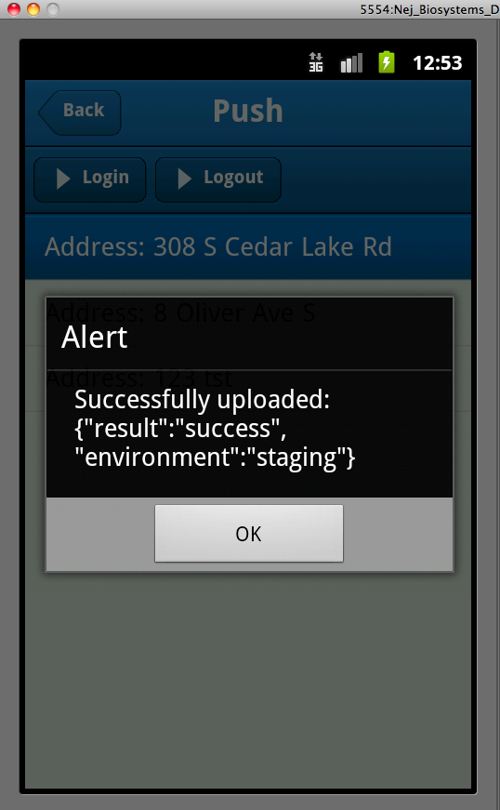

Then if it exists, the image associated with the evaluation will automatically be uploaded and a message indicating success will be displayed.
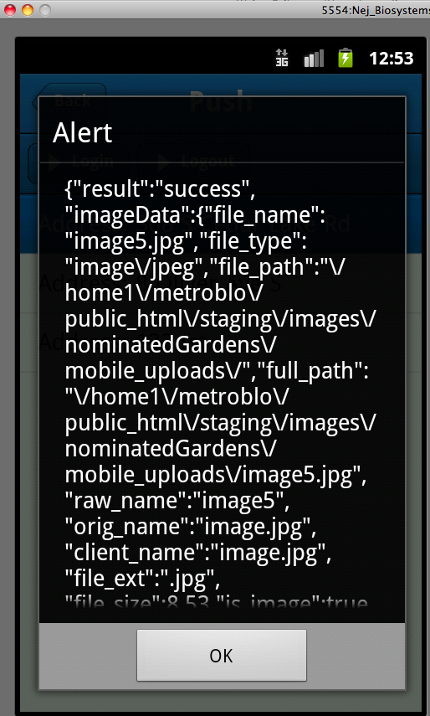

NB: Currently, there is no way to track on the mobile device if an evaluation and its image have been uploaded (the only way is to view your evaluations on the Metro Blooms Web site). Each time you tap on a completed evaluation's address and tap on the “Push to server” button it will update the associated record, including any image, to the Metro Blooms Web server, so please be careful when using this feature.

To do

- destroy record
- flag as uploaded

Problems and Errors

If you encounter any problems or issues, please try to carefully document the steps to reproduce and the behavior encountered.

